**DESIGN AND IMPLEMENTATION OF AN IOT-BASED PATIENT HEALTH MONITORING SYSTEM**

**BY**

**JACOB ADABARA DANIEL**

**VUG/CSC/20/4446**

**A PROJECT TO THE DEPARTMENT OF COMPUTER AND INFORMATION TECHNOLOGY, FACULTY OF NATURAL AND APPLIED SCIENCES, VERITAS UNIVERSITY, ABUJA, IN PARTIAL FULFILMENT OF THE REQUIREMENTS FOR THE AWARD OF THE BACHELOR OF SCIENCE DEGREE (B.Sc.) IN COMPUTER SCIENCE**

## **DECLARATION**

I, JACOB ADABARA DANIEL with matriculation number VUG/CSC/20/4446 hereby declare that I Carried out this project work titled DESIGN AND IMPLEMENTATION OF AN IOT BASED PATIENT HEALTH MONITORING SYSTEM, which has been carried out by me under the supervision of ENGR. CALISTUS CHIMEZIE and that this work has not been previously submitted for the award of any degree in this or any other university.

**JACOB ADABARA DANIEL _**___________________ ____________________

Signature Date

## **CERTIFICATION**

This is to certify that the project titled” **DESIGN AND IMPLEMENTATION OF AN IOT BASED PATIENT HEALTH MONITORING SYSTEM** “under the supervision of **ENGR. CALISTUS CHIMEZIE**. All sources of information are specifically acknowledged using reference.

__________________________ ________________________

ENGR. CALISTUS CHIMEZIE DATE

**(Project Supervisor)**

____________________________ __________________________

DR. JOE ESSIEN DATE

**(Head of Department)**

_____________________________ _________________________

PROF. SIMON OKWUTE DATE (**Dean, Faculty of Natural and Applied Sciences)**

_________________________ __________________________

PROF. OLUMIDE OWOLABI DATE

**(External Examiner)**

## **DEDICATION**

I dedicate this work first of all to God Almighty, the fountain and source of my inspiration and knowledge, for guidance and protection over me. I also dedicate this work to my lovely parents, LATE MR. JACOB USMAN & MRS. JOAN JACOB***.*** I also dedicate this work to my supervisor; ENGR CALISTUS CHIMEZIE who has encouraged me all the way and whose encouragement has made sure that I give it all it takes to finish that which I have started. And to my sister Miss Favour Oiza Jacob for her assistance and guidance.

My gratitude to my friends Lawal Olanrewaju Rilwan, Omonubi Oluwatomiwa Emmanuel, Agbasi Chukwuebuka Justin, Hannah Yakubu Buba, Okochi Emunah and many more for the support encouragement throughout this project. Also to Engr. Oyedele Adekunle Isaac and Engr. Hafiz Salman for his extended support.

## **ACKNOWLEDGEMENT**

This initiative will not be complete unless heartfelt gratitude is expressed to all who have made it a success. First and foremost, I appreciate God for providing me with life, wisdom, good health, and strength during this era. My heartfelt thanks also go to my project supervisor, ENGR. CALISTUS CHIMEZIE, for his helpful recommendations and assistance. I also like to thank the staff and instructors of Programming for their help throughout the years. I am extremely grateful to my parents for their prayers, unwavering love, kindness, and understanding over the years. I also want to thank all of my friends for their understanding over this period.   
My admiration also goes to the Head of the Department of Computer and Information Technology, Dr. Joe Essien, a hardworking and kind man; I sincerely appreciate MR. THOMAS BAIDOO, MR. ENOCH OJINIMI, MR ERIC TANIFORM; all of whom I have had direct contact with and who have impacted me during this program. I say a big thank you.

Table of Contents

**DECLARATION** 2

**CERTIFICATION** 3

**DEDICATION** 4

**ACKNOWLEDGEMENT** 5

**ABSTRACT** 7

**CHAPTHER ONE** 8

1.0 **BACKGROUND……………………………………………………………………………….** 8

1.2 **RESEARCH MOTIVATION** 8

**1.4** **RESEARCH QUESTIONS** 10

1.5 **RESEARCH AIM AND OBJECTIVES**. 10

1.6 **SIGNIFICANCE OF THE RESEARCH** 11

**1.7 SCOPE OF STUDY** 13

**1.8 LIMITATION OF THE RESEARCH:** 14

**1.9 ORGANIZATION OF THE PROJECT** 15

**CHAPTER TWO** 15

**LITERATURE REVIEW** 15

**2.1 INTRODUCTION** 15

**2.2 LITERATURE REVIEW** 16

**CHAPTER THREE** 22

**RESEARCH METHODOLOGY** 22

**3.1 Problem Statement** 22

**3.2 Objectives** 22

**3.3 Data Collection** 23

**3.4 Data Cleaning and Analysis** 23

**3.5 Develop a Model** 24

**3.6 Analyze Alternatives** 25

3.7 Recommend a Solution 26

**3.8 Implement and Monitor** 28

**3.8.1 Implementation** 28

**3.8.2 Monitoring and Adjustments** 29

**CHAPTER FOUR** 30

**4.0 INTRODUCTION:** 30

**4.1 PRELIMINARY ANALYSIS ON IOT BASED PATIENT HEALTH MONITORING SYSTEM** 32

**4.2 Hardware Design** 33

**4.3 Block Diagrams** 34

**4.4 Arduino Uno Microcontroller** 35

**4.5 Heartbeat Sensor** 35

**4.6 Body Temperature Sensor** 36

**4.7 ESP8266 Wi-Fi Module** 37

**4.8 RESISTORS** 38

**4.9 SYSTEM MODE OF OPERATION** 39

**4.10 SIMULATION ENVIRONMENT** 42

**4.11 PROTEUS SIMULATION** 43

**4.12 INTERFACE FOR DATA STORAGE** 43

**4.13 RESULTS AND ANALYSIS** 44

**CHAPTER FIVE** 47

**5.1 SUMMARY** 47

**5.2 RECOMMENDATION** 47

**5.3 LIMITATION OF THE WORK** 48

**5.4 FURTHER WORK** 49

**5.5 CONCLUSION** 51

**REFERENCES** 51

**APPENDIX** 53

**ABSTRACT**"IoT Based Patient Health Monitoring System" is a cutting-edge healthcare solution that harnesses the Internet of Things (IoT) for real-time monitoring of patients' health. At the heart of this system is ThingSpeak, an IoT platform that facilitates data collection, processing, visualization, and analysis.

The system employs smart sensors, including pulse and temperature sensors, to capture vital signs. The pulse sensor is used to measure heart rate, an essential indicator of cardiovascular health. The temperature sensor, on the other hand, monitors body temperature, alerting healthcare providers to possible fever or hypothermia.

The key link between these sensors and the ThingSpeak platform is the ESP8266 Wi-Fi module. This compact yet powerful module enables the transmission of collected data to the IoT platform over Wi-Fi. The ESP8266 is not only efficient and reliable but also cost-effective, making it an ideal choice for IoT applications.

Once the data is transmitted to ThingSpeak, it is stored, processed, and visualized in a user-friendly format. Healthcare professionals can then access this information remotely, enabling them to keep a close eye on the patient's condition and intervene promptly if necessary.

This IoT-based system revolutionizes healthcare delivery by providing continuous, remote health monitoring. It eliminates the need for frequent hospital visits, offers immediate response to health changes, and ultimately promotes patient comfort and well-being. In a nutshell, it paves the way for a more efficient, personalized, and patient-centric approach to healthcare.

## **CHAPTHER ONE**

## **BACKGROUND** The healthcare industry is undergoing a significant transformation driven by the integration of technology. The Internet of Things (IoT) has emerged as a powerful tool for revolutionizing patient care, particularly in the realm of remote health monitoring (Ray et al., 2021). Traditional healthcare often relies on periodic in-person consultations, which can be inconvenient for patients and limit the amount of data collected (Atef et al., 2018). IoT-based patient health monitoring systems offer a compelling alternative by enabling continuous, real-time data collection from a patient's vital signs and other health parameters, can also collect vital signs and health data from patients remotely, enabling EMS personnel to identify and respond to potential emergencies before they escalate.

## 1.2 **RESEARCH MOTIVATION**

The fragmented nature of traditional healthcare, with patients often seeing multiple specialists across different institutions, creates significant challenges. Disrupted continuity of care can lead to miscommunication between providers, resulting in conflicting diagnoses or treatments. Patients may undergo repetitive testing because one provider isn't aware of results from another. This lack of a cohesive view of a patient's health history and current condition can also cause delayed diagnoses and inefficient treatment plans, as crucial details from previous encounters might not be readily available.

IoT-based patient health monitoring systems offer a powerful solution to bridge these gaps and enhance continuity of care. These systems continuously collect and transmit vital signs and physiological data through sensors worn by patients or embedded in their surroundings. This data is then securely shared with a patient's entire network of healthcare providers, creating a centralized, constantly updated record. By integrating data from various sources (home monitoring, doctor visits, wearables), healthcare professionals gain a more comprehensive understanding of a patient's health trajectory, including trends and potential areas of concern.

Improved communication and collaboration are facilitated through a shared platform that allows providers to discuss treatment plans and patient progress efficiently. With readily available, complete health data, the risk of misdiagnoses and unnecessary procedures based on incomplete information is minimized.

The benefits of improved continuity of care with IoT-based monitoring are numerous. By continuously tracking health data, subtle changes that might indicate potential issues can be detected and addressed proactively, leading to early identification of trends and potentially preventing complications. A more holistic view empowers providers to tailor treatment plans to a patient's specific needs and adjust them in real-time based on ongoing data collection. This personalized approach can lead to better patient outcomes. Additionally, improved care coordination and early intervention can lessen the need for hospital readmissions due to preventable complications. Finally, patients feel more empowered when healthcare providers have a complete picture of their health. This allows for better communication, shared decision-making, and overall improved patient satisfaction.

## **1.3 PROBLEM STATEMENT** An IoT-Based Patient Health Monitoring System seeks to transform healthcare delivery by leveraging the capabilities of the Internet of Things (IoT). However, the primary issue identified is a knowledge gap that prevents the smooth integration of IoT for real-time patient health monitoring, efficient handling of extensive healthcare data, and prompt intervention deployment (Atef et al., 2018). While existing literature provides a basis for IoT applications in healthcare, demonstrating the potential of wearable devices, sensors, and data analytics, the practical execution of IoT-based patient health monitoring systems encounters a significant challenge. This is marked by a lack of comprehensive and interoperable solutions capable of delivering continuous, real-time patient data to healthcare providers and facilitating timely interventions. This problem statement acknowledges the urgent need to develop an innovative and up-to-date IoT-Based Patient Health Monitoring System that can overcome existing healthcare limitations. The aim is to bridge the critical knowledge gap by creating a seamless, secure, and patient-focused platform that can harness the IoT's potential for real-time monitoring, data analysis, and the provision of proactive healthcare services.

## **RESEARCH QUESTIONS**

This research is positioned to revolutionize healthcare by harnessing the power of the Internet of Things (IoT). However, a critical issue identified in the background is the existing knowledge gap that impedes the seamless integration of IoT for real-time patient health monitoring, efficient management of large-scale healthcare data, and the swift deployment of interventions.

* Can ESP8266 with temperature and pulse sensors accurately monitor vital signs compared to clinical equipment in an IoT healthcare system?
* How can security of patient data be improved in an ESP8266 based IoT health monitoring system for real-time monitoring?

## **RESEARCH AIM AND OBJECTIVES** The primary aim of the IoT-Based Patient Health Monitoring System project is to introduce a innovative healthcare solution by leveraging the capabilities of the Internet of Things (IoT). This transformative initiative aims to reshape patient care, streamline healthcare procedures, and enable real-time health data monitoring, all with the goal of enhancing healthcare outcomes. In line with this overarching aim, the research objectives are set forth, guiding the project towards specific, measurable goals.

The Objectives of this project include:

**Secure and scalable. IoT Infrastructure:** Create and install a strong and secure Internet of Things (IoT) infrastructure capable of supporting the needs of a patient health monitoring system..

**Seamless Wearable Device Integration**: Enable seamless integration of various wearable health monitoring devices with the developed IoT platform. This ensures the system can collect data from a diverse range of sensors and devices used by patients.

**User-Friendly Patient Interface:** Develop a user-friendly interface on the IoT platform that is accessible and easy for patients to navigate. This interface will likely allow patients to view their health data, track trends, and potentially interact with the system in other meaningful ways.

**Real-time Data Collection and Analysis:** Establish a central server system capable of collecting real-time data from wearable devices. This server should also have the capability to analyze the collected data in real-time, potentially providing valuable insights for healthcare providers.

## 1.6 **SIGNIFICANCE OF THE RESEARCH**

The research on an "IoT-based Patient Health Monitoring System" holds significant importance, as it contributes both to existing theoretical literature and practical industry applications. Here is an analysis of the research's contributions to these two realms:

**1. Advancements in Theoretical Literature:**

**a. Enhanced Healthcare Management**: The study adds to the theoretical literature by offering insights into the integration of IoT technologies in healthcare. It contributes to the development of a framework for better patient health monitoring by continuously collecting and analysing real-time health data. This can help in early diagnosis and prevention of health issues, as well as improve understanding of illness progression and therapy.

**b.** **Improved understanding of health:** By monitoring a wider range of physiological data (heart rate, blood pressure, oxygen saturation, respiration rate, etc.) and environmental factors (temperature, humidity, sleep patterns, activity levels, medication adherence), researchers can gain a more holistic understanding of how these elements influence health. This can lead to the development of more comprehensive models of health and disease, and the identification of new risk factors for chronic conditions.

**c.** **Validation of existing theories:** Real-time data collected by IoT-based PHMS can be used to validate existing hypotheses about health and disease in a more comprehensive and generalizable way than traditional research methods. For example, researchers could use PHMS data to investigate the relationship between sleep quality and heart disease risk, or between physical activity levels and blood sugar control in diabetic patients. By monitoring large numbers of patients over time, researchers can identify patterns and correlations that would be difficult to detect in smaller, more controlled studies. This can help to strengthen the theoretical foundation of medicine and inform the development of new diagnostic tools and treatment approaches.

**d. Privacy and Security**: IoT in healthcare raises concerns about patient data security and privacy. The research adds to the theoretical literature by addressing these issues and proposing solutions. This knowledge contributes to the establishment of guidelines and best practices in ensuring the confidentiality and security of patient data.

**2. Advancements in Industry (Practice):**

**a. Improved Patient Care:** The practical significance of this research is profound, as it directly impacts patient care. An IoT-based patient health monitoring system enables healthcare professionals to monitor patients remotely, facilitating timely interventions and reducing hospital readmissions. This improves the quality of care while reducing healthcare costs.

**b. Telemedicine:** In an age where telemedicine is becoming increasingly important, IoT-based monitoring systems provide a vital link between patients and healthcare providers. This research contributes to the development of telemedicine practices, making healthcare more accessible and efficient, especially for remote and underserved areas.

**c. Wearable and Connected Devices:** The industry benefits from the development of new wearable and connected healthcare devices. These devices can be marketed and integrated into patient care, giving healthcare companies opportunities to create innovative solutions for the market.

**d. Healthcare Infrastructure:** The implementation of IoT-based systems requires advancements in healthcare infrastructure, such as data centers, network connectivity, and interoperability standards. The research contributes to the development and optimization of this infrastructure, which benefits healthcare institutions and technology providers alike.

**e. Reduced healthcare costs:** Early detection of health issues through IoT-based PHMS can help prevent costly complications and hospital admissions. For example, continuous monitoring of blood sugar levels in diabetic patients can help identify trends and prevent diabetic ketoacidosis, a serious and potentially life-threatening condition. Similarly, remote monitoring of heart rate and blood pressure can help identify patients at risk for heart failure or stroke, allowing for early intervention and treatment to prevent these costly events. Additionally, IoT-based PHMS can reduce healthcare costs by enabling more efficient use of healthcare resources. For instance, by remotely monitoring chronically ill patients, healthcare providers can avoid unnecessary hospital visits and admissions. Furthermore, PHMS data can be used to identify patients who are most likely to benefit from certain interventions, such as medication adjustments or lifestyle changes, which can help to optimize care delivery and reduce overall healthcare costs.

In conclusion, the research on an "IoT-based Patient Health Monitoring System" offers significant contributions to both theoretical literature and practical industry applications. It not only expands our understanding of healthcare technology but also has the potential to revolutionize patient care and healthcare management. These advancements hold promise for improving healthcare outcomes and reducing the burden on healthcare systems.

## **1.7 SCOPE OF STUDY**

This project aims to develop an Internet of Things (IoT) based system for remote patient health monitoring. The system will leverage readily available sensors to track a patient's vital signs, allowing for improved healthcare delivery and patient care. By utilizing a pulse sensor and a temperature sensor, the system will collect essential health data. This data will be processed by a microcontroller unit (MCU), which acts as the brain of the system. The MCU will then securely transmit the information via a Wi-Fi module to a designated IoT platform. This platform serves as a central hub, storing the collected data and enabling visualization and analysis. Authorized personnel, such as patients, doctors, and caregivers, can access the platform through a user-friendly interface (UI) like a mobile application or web dashboard.

While the initial development will focus on a core set of vital signs collected from a specific patient group, the system holds the potential for expansion. Additional sensors can be integrated to monitor a wider range of health parameters in the future. The project will prioritize user-friendliness and cost-effectiveness for widespread adoption. It's important to note that the project scope excludes advanced medical diagnosis or comprehensive security penetration testing. However, the system will be equipped with secure data transmission protocols to safeguard patient privacy. The expected outcomes of this project encompass the development of a user-centric system for remote patient monitoring. This system will provide real-time data access, enabling proactive healthcare delivery through informed decision-making by medical professionals. Ultimately, the project object to improve patient care and contribute to a more efficient healthcare system.

## **1.8 LIMITATION OF THE RESEARCH:**

This system offers a promising approach to remote healthcare, but inherent limitations require consideration. Sensor accuracy and reliability can be affected by placement, movement, or calibration, potentially hindering definitive diagnoses. Robust data security protocols are essential to safeguard sensitive patient information, as vulnerabilities could lead to privacy breaches. Dependence on Wi-Fi connectivity limits the system's reach to areas with poor internet access or for patients lacking Wi-Fi at home. Additionally, technical proficiency is required for patients to interact with the system effectively. Battery life and power management pose challenges, as frequent changes or reliance on constant power sources can be inconvenient. Finally, the initial focus on a core set of vital signs limits the system's ability to comprehensively monitor a broader range of health parameters.

However, these limitations can be addressed through thoughtful design choices. Employing data validation techniques can help ensure sensor readings are accurate. Prioritizing robust encryption and secure data storage protects patient privacy. Alternative communication protocols like Bluetooth or cellular networks can provide backup options in areas with weak Wi-Fi. User-friendly interfaces and educational resources can bridge the technology gap for patients with limited technical skills. Exploring low-power sensors and optimizing power consumption can extend battery life and reduce reliance on constant power sources. Finally, the system can be designed with modularity in mind, allowing for future integration of additional sensors to monitor a wider range of health parameters. By acknowledging and addressing these limitations, you can create a more robust and user-centric IoT-based patient health monitoring system with the potential to significantly improve remote healthcare delivery.

## **1.9 ORGANIZATION OF THE PROJECT**

This project work is divided into five chapters. Chapter one illustrates the project, and discusses the background and motivation for the work. It also showcases the research problem, aims, and objectives of the research, the significance of the study, and the scope of the study. Chapter two explains the Literature review for the project. Chapter three explains the operational research. Chapter four covers the design, implementation and documentation of the proposed project. Chapter five concludes with the summary and conclusion.

## **CHAPTER TWO**

## **LITERATURE REVIEW**

## **2.1 INTRODUCTION**

This chapter will explain the basics and theories related to an IOT based patient health monitoring system shedding more light about the existing health monitoring system that have been implemented.

## **2.2 LITERATURE REVIEW**

In recent years, there has been a growing need to optimize resources and improve healthcare services due to the increase in global infectious diseases, population growth, and life expectancy. Automated disease monitoring, diagnosis, prediction, and treatment have become essential for efficient and cost-effective healthcare delivery. The combination of wearable devices and the Internet of Things (IoT) has revolutionized the medical system by enabling real-time monitoring and providing ubiquitous healthcare services. (Awotunde et al, 2021)

However, the integration and design of IoT-based wearable sensors present various challenges, particularly in the areas of data exchange, monitoring, and diagnosing patients. To address these challenges, a framework is proposed in this chapter that combines IoT and wearable body sensors with machine learning algorithms (ML). The data collected from different wearable sensors, such as body temperature, glucose sensors, heartbeat sensors, and chest sensors, are transmitted through IoT devices to an integrated cloud database. (Awotunde et al, 2021)

The Internet of Things (IoT) has played a significant role in monitoring and controlling the spread of the virus. AI algorithms have been employed to process data collected from IoT devices and sensors, enabling real-time monitoring, contact tracing, and early detection of potential outbreaks. Computational biology and medicine have also benefited from AI techniques, aiding in drug discovery, vaccine development, and understanding the virus's behavior. (Nguyen et al, 2020)

The significant impact of Internet of Things (IoT) communication technologies in various domains, particularly in the second phase of the digital revolution. It highlights the scalability and data management challenges that arise due to the integration of a large number of devices within IoT networks. Orchestration is presented as an automated approach to address these challenges effectively. (Imran et al, 2021)

Wireless sensor networks (WSNs), machine-to-machine (M2M) communication, and cyberphysical systems (CPS) are identified as key elements of IoT. The use of standard IP protocols with security measures is emphasized to ensure the safety of the entire network against cyberattacks that can compromise IoT services, data security, privacy, and integrity. (Imran et al, 2021)

IoT technology plays a crucial role in monitoring the health of coma patients. Continuous fitness monitoring can save up to 60% of human lives through early detection. The device tracks coma patients' health metrics in real-time. The use of GSM and IoT is more suitable for recognizing patient state and condition.  
The proposed method uses smart sensors such as temperature, heartbeat, eye blink, and SPO2 (Peripheral Capillary Oxygen Saturation) to measure a patient's body temperature, heart rate, eye movement, and oxygen saturation. This system utilizes the ARDUINO-UNO board as a microcontroller and Cloud computing. A cloud server transmits the patient's vital parameters to the legal individual's smartphones and laptop computers. These recordings can be retained and evaluated for future review and selection.(Tamilselvi V. 2020)

This paper presents a proposed venture which makes use of temperature and pulse rate sensor to degree the body temperature and pulse rate that is a critical parameter for seriously ill sufferers. So that health practitioner will monitor and may immediately take action straight away. If the circumstance turns into essential, the physician is alerted so that he can treat patient immediately.(*Divya Priya, S Sundar. 2019)*

Ensuring good health is a universal aspiration, emphasizing the need for regular health monitoring to detect potential issues. In the face of modern challenges like long hospital queues, a basic health monitoring system is essential, leveraging advanced technology such as the Internet of Things (IoT). This project utilizes IoT to capture and transmit crucial health data, analyzing parameters like body temperature and blood pressure. The Arduino Board processes collected data, which is then transmitted over the internet for analysis. In critical situations, automatic notifications are sent to healthcare professionals.( *P. Saleem Akram, Ramesha. M. 2021)*

Smart and connected healthcare, driven by the Internet of Things (IoT), is crucial for gathering rich information on physical and mental health through networked sensors. This paper focuses on current IoT methods for healthcare and proposes a Mobile-IoT-centered system. It collects patient data from diverse sensors, sending timely alerts to guardians and doctors via emails and SMS. The system enables remote monitoring of physiological parameters, facilitating swift illness diagnosis and promoting a proactive healthcare paradigm.( C R Srinivasan, Guru Charan, P Chenchu Sai Babu. 2019)

In today's healthcare landscape, Wireless-Sensing node Technology is crucial for science and knowledge advancement. To address unforeseen fatalities, especially among elderly patients with heart issues, we propose an innovative Patient Health Monitoring system using sensor technology and internet communication. The system, featuring Temperature and heartbeat sensors connected to an Arduino-uno, sends real-time data to a web server for monitoring. In case of abnormal changes, IoT alerts are sent, providing an effective means of healthcare monitoring.(D.Shiva Rama Krishnan. June 2018)

This paper presents the design and implementation of a wireless biomedical parameters monitoring system using various sensors and Arduino UNO as the MCU (Master Control Unit). The system can be used to continuously monitor the biomedical parameters of a patient wiz. The body temperature and pulse rate from anywhere on the globe using IoT (Internet Of Things). IoT is implemented using an ESP WiFi module, which allows the various signals to be transmitted seamlessly over the internet. The device is portable and can be powered by a 5 V DC source.

The economic potential of IoT has led to research and advancements in IoT technologies by IT organizations and academic institutes. However, the lack of adaptability among IoT application development platforms has resulted in data format heterogeneity, requiring better network management solutions. Edge computing solutions are highlighted as essentials for analyzing data and refining IoT utilities. The emergence of big data solutions in IoT introduces practical applications based on the vast amount of data generated by IoT devices. (Imran et al, 2021)

Various challenges in IoT, such as security, privacy, IoT-cloud integration, standardization, scalability, and architecture. Imran et al also introduces machine learning, blockchain, and their integration with IoT in the healthcare domain. Artificial Intelligence of Things (AIoT) is described as a combination of AI and IoT, aiming to enhance human-machine interactions, data management, and analysis. Machine learning algorithms are utilized for anomaly detection, pattern recognition, and efficient network services provisioning. (Imran et al, 2021)

Overall, the IoT-WBN-based framework with machine learning algorithms offers a comprehensive solution for remote healthcare monitoring and diagnosis. It holds great potential for application in remote areas where access to healthcare facilities is limited. By leveraging wearable sensors, IoT connectivity, and ML analysis, the framework facilitates timely and accurate healthcare services, ultimately improving patient outcomes and healthcare system efficiency. (Awotunde et al, 2021)

The proposed system uses diverse techniques that monitor the well-being of the elderly and disabled humans. There are lot of statistics mining techniques that are being used for the data which is received from such things as smart meter, equipment utilization, and video surveillance. Random forest and VSM are suggested to be the excellent models that may be utilized in M-Health care prediction to get the accurate human activity recognition. (*Jose Reena K, R. Parameswari. 2019)*

Numerous IoT-based health monitoring projects use remote sensors, including a patient monitoring system initially developed with an Atmega-8 microcontroller and sensors like temperature, ECG, and heart rate. The system, now utilizing Arduino Uno, efficiently collects, stores, and processes sensor data. Challenges include the need for high-quality data in unpredictable environments. Embedded sensors on the body enable non-disruptive monitoring, involving sensors, a microcontroller, display, and GSM modem for emergency communication. At the doctor's office, a GSM modem streamlines result communication to patients and their families, ensuring swift and accurate reporting. Some devices integrate GSM modules into pulse monitoring gadgets, sending vital data via SMS for practical health monitoring at different levels. (*K. Teja Samba Siva Rao, Sai Aamani Sindhu Valiveti. 2021)*

Technology plays the foremost role in healthcare not only for sensory devices but also in communication and recording. It is vital to observe varied medical parameters and post operational days. So the most recent development in healthcare communication methodology, IoT is customized. IoT is a catalyst for the healthcare and plays distinguished role in many applications. In this project, microcontroller is used as a gateway for communication. This system puts forward a wise patient health monitoring system that uses sensors to trace patient health and uses internet to intimate their loved ones or concerned doctors in case of any emergency. The controller is additionally connected with a buzzer to alert the caretaker regarding variation in detector output. The sensors are connected to a microcontroller to trace the status of the patient which in turn is interfaced with LCD display furthermore as wireless local area network association so as to transmit alerts. If the system detects any changes in patient pulse rate or BP, the system automatically sends an alert to the doctor regarding the patient status over IoT and additionally shows the details of heartbeat, BP and temperature of patient, live over the cloud. So IoT based patient health monitoring system effectively uses internet to watch patient health status and save lives on time. For this reason fast conditional medication may be simply done by this technique. This system is easy to setup and is capable of high performance and time to time response. (Malathi M, Preethi D. 2019)

Health is the biggest worldwide problem for humanity. Over the last decade the healthcare has drawn significant amount of attention. The major and supreme objective is to design precise automated patient's health monitoring system so that the doctors or healthcare service provider can analyze and monitor the patients, who are either hospitalized or performing their usual day-to-day life fuss. As an outcome, visit of healthcare professionals to the patients constantly drops as the statistics or records regarding patient’s health straightly comes to healthcare professional’s smartphone over an android application, no matter wherever the patient is settled. Also, based on this record, healthcare providers could diagnose numerous lives by providing them a swift and valuable service. (Sahil Taneja. 2019)

The widespread use of mobile technologies and smart devices in healthcare has revolutionized critical care worldwide. Health professionals harness these advancements to improve healthcare delivery in clinical settings, while users benefit from M-Health and E-Health applications to support their well-being. The Internet of Things facilitates real-time health monitoring, enabling devices to provide continuous health data to doctors. The goal of the 'Patient Monitoring System' is to monitor vital signs such as body temperature, heart rate, and pulse oximetry, along with fall detection and sleep pattern analysis. The system utilizes various sensors to monitor these vital signs, transmitting data to the cloud for real-time analysis. It also has the capability to alert doctors via their mobile or web portal in case of emergency signs, facilitating prompt intervention. (Shola usha rani. 2017)

In today's healthcare landscape, the absence of timely medication and monitoring poses significant challenges. However, electronic-based technologies and IoT devices offer a solution by enabling remote health monitoring over the internet. In India, experts have leveraged these smart devices to monitor patients' health conditions effectively. This paper introduces a kit based on these technologies, capable of measuring various physiological parameters such as blood pressure, temperature, heartbeat, pulse rate, brain and muscle activity, sweat gland activity, and blood oxygen levels. The collected data is transmitted via internet connectivity, allowing healthcare providers to monitor, control, and analyze the patient's health continuously from a distance. (Praveen Kumar Maduri, Durga Yadav, Kushagra Singh. 2020)

Covid-19 has exposed the necessitate for the rapid acceptance of increasingly pioneering digital health technologies, especially remote health monitoring. The digital revolution in Healthcare is dynamic ease of use of inexpensive concern solutions, enhancing patient care, reducing complications, improving effectiveness, and authorizing healthcare decision-makers with intelligence insight at the point of care. (Ahmed J. Obaid)

The research describes the global impact of the COVID-19 pandemic and the challenges faced by governments worldwide. It mentions the scarcity of resources, overburdened healthcare systems, and the implementation of lockdown measures in many countries. It acknowledges the rapid increase in laboratory-confirmed cases of COVID-19 globally, with more than 3 million confirmed cases as of April 30, 2020. (Chamola et al, 2020)

Another issue highlighted is the circulation of false reports, misinformation, and fears surrounding the virus. To address this, the authors aim to provide a comprehensive review of all major aspects associated with the COVID-19 pandemic, drawing on reliable sources. (Chamola et al, 2020)

Furthermore, it emphasizes the impact of the pandemic on the global economy. It suggests that in addition to the direct health implications, the study will explore the potential use of various technologies such as IoT, UAVs, blockchain, AI, and 5G to mitigate the impact of the COVID-19 outbreak. (Chamola et al, 2020)

The research sets the context for a comprehensive review that covers various aspects of the COVID-19 pandemic, including health implications, economic impact, and the potential use of emerging technologies to address the challenges posed by the outbreak. (Chamola et al, 2020)

## **CHAPTER THREE**

## **RESEARCH METHODOLOGY**

**Methodology: Defining the Problem and Objectives**

## **3.1 Problem Statement**

The growing population and increasing prevalence of chronic diseases strain healthcare systems globally. Traditional healthcare models often rely on periodic check-ups, which may not capture the complete picture of a patient's health. This can lead to delayed diagnoses and interventions.

This project aims to address this challenge by developing an IoT-based patient health monitoring system. ([Singh et al., 2022])

## **3.2 Objectives**

The primary objective of this project is to design and implement an IoT-based patient health monitoring system that offers the following benefits:

**Improved Patient Care:** Enable continuous monitoring of vital signs (e.g., heart rate, blood pressure, oxygen saturation) for timely detection of potential health issues. ([Yu et al., 2020])

**Enhanced Remote Monitoring:** Allow healthcare providers to remotely track patient health data, facilitating early intervention and improved care coordination. ([Ray et al., 2018])

**Increased Patient Empowerment:** Provide patients with real-time insights into their health data, promoting self-management and informed decision-making. ([Chen et al., 2019])

The success of this project will be measured by its ability to achieve these objectives. We will evaluate the system's effectiveness based on:

**Data Accuracy:** Ensuring collected health data is accurate and reliable for clinical decision-making.

**Real-time Monitoring:** Capability of the system to provide continuous and uninterrupted data collection.

**User-friendliness:** Ease of use for both patients and healthcare providers.

**Scalability:** Potential for the system to be adapted and implemented in various healthcare settings.

## **3.3 Data Collection**

For the development of our IoT-based patient health monitoring system, data collection will be crucial from various sources to understand user needs, system performance, and identify potential areas for improvement. Here's a breakdown of the planned data collection methods:

* **User Surveys:** Conduct surveys with patients and healthcare providers to gather insights into their needs, preferences, and potential concerns regarding the system's functionalities and user interface design. This will help us tailor the system to be user-friendly and meet the expectations of both target audiences. ([Yu et al., 2020])
* **Sensor Data Collection:** Develop and implement mechanisms to collect real-time health data from various sensors integrated into the system (e.g., wearables, smart devices). This data might include vital signs like heart rate, blood pressure, oxygen saturation, and sleep patterns. By collecting this health data, we can gain a deeper understanding of a patient's health status and identify potential trends or anomalies that might warrant further investigation by healthcare professionals.
* **System Log Data:** The system will be designed to record log data about its operation, including system uptime, sensor connectivity status, and any error messages encountered. This data will be valuable for troubleshooting and system performance analysis. By monitoring system logs, we can proactively identify and address any technical issues that might hinder the system's functionality and ensure it delivers reliable health data.

## **3.4 Data Cleaning and Analysis**

Once collected, the data will undergo a rigorous cleaning and organization process to ensure its quality and usefulness for analysis. This will involve:

* **Data Cleaning:** Identify and address any missing values, outliers, or inconsistencies within the data set. Techniques like data imputation and filtering might be employed.
* **Data Integration:** Combine data from different sources (surveys, sensor data, system logs) into a unified format for comprehensive analysis.
* **Data Visualization:** Present the data visually using charts, graphs, and dashboards to identify trends, patterns, and potential correlations between various data points.
* **Data Mining:** Leveraging data mining techniques can help uncover hidden insights and relationships within the data set. This could be used to identify potential risk factors for patients or optimize system performance.

## **3.5 Develop a Model**

For our IoT-based patient health monitoring system focusing on temperature and pulse, developing a mathematical model might not be directly applicable in the same way as resource allocation or queuing models. However, we can create a conceptual model to represent the system's functionality and data flow.

This conceptual model will outline the key components and their interactions within the system. Here's a breakdown of the model:

* **Sensors:** This includes the temperature sensor and pulse oximeter responsible for collecting patient data. The model will specify the type of sensors used, their data acquisition frequency, and any relevant parameters associated with sensor operation (e.g., measurement range, accuracy).
* **Data Acquisition Unit (DAU):** This component is responsible for collecting raw data from the sensors and performing any necessary pre-processing (e.g., signal filtering, calibration). The model will outline the data processing steps within the DAU.
* **Microcontroller Unit (MCU):** The MCU acts as the central processing unit of the system. The model will specify the functionalities of the MCU, including data storage, communication protocols used to transmit data to the cloud platform, and any local processing or analysis performed on the device.
* **Cloud Platform:** The cloud platform serves as a central repository for storing and managing collected patient data. The model will specify the chosen cloud platform and the security protocols used to ensure data privacy and integrity.
* **User Interface (UI):** This component provides an interface for patients and healthcare providers to access and visualize the collected health data (temperature and pulse). The model will outline the functionalities of the UI, including data visualization tools, alert notifications, and potential functionalities for user interaction (e.g., setting thresholds for abnormal readings).

This conceptual model will serve as a blueprint for system development, ensuring all components work together seamlessly to collect, transmit, store, and visualize patient health data. It will also be a valuable tool for communication, allowing all stakeholders involved in the project (developers, healthcare professionals, patients) to have a shared understanding of the system's functionalities and data flow.

## **3.6 Analyze Alternatives**

Utilizing the conceptual model developed for our IoT-based patient health monitoring system focused on temperature and pulse, we can analyze alternative approaches for system design and implementation.

Here's how we can evaluate different courses of action:

* **Sensor Selection:** The model can be used to compare different temperature sensor and pulse oximeter options based on factors like:
  + **Accuracy:** Evaluate the level of accuracy required for temperature and pulse readings to ensure reliable health data collection.
  + **Power Consumption:** Consider the trade-off between sensor accuracy and power consumption, especially if the system is designed for continuous monitoring and battery life is a concern.
  + **Cost:** Analyze the cost implications of different sensor options to ensure the system remains affordable for patients and healthcare institutions.
* **Data Acquisition Unit (DAU) Design:** The model can be used to evaluate different data pre-processing techniques within the DAU. This could involve simulations to assess the impact of filtering algorithms on noise reduction and data integrity.
* **Communication Protocols:** The model can be used to compare various communication protocols (e.g., Bluetooth, Wi-Fi) for data transmission between the MCU and the cloud platform. Factors like:
  + **Range:** Consider the required transmission distance between the patient and the data receiving device.
  + **Power Consumption:** Evaluate the power efficiency of different protocols to optimize battery life.
  + **Security:** Analyze the security protocols offered by each communication option to ensure patient data privacy and integrity during transmission.
* **Cloud Platform Selection:** The model can be used to assess different cloud platforms based on factors like:
  + **Scalability:** Consider the potential growth of the system and the chosen platform's ability to handle increasing data volumes.
  + **Security Features:** Evaluate the cloud platform's security measures to ensure patient data remains protected.
  + **Cost:** Analyze the pricing structure of different cloud platforms to choose a cost-effective option.

By analyzing these alternatives through the lens of the conceptual model, we can make informed decisions about system design and implementation, optimizing factors like accuracy, efficiency, security, and cost-effectiveness for the specific needs of the IoT-based patient health monitoring system.

## **3.7 Recommend a Solution**

Based on the analysis of alternatives conducted in the previous section, we can now recommend a solution that best achieves the project's objectives while considering constraints like budget and resources. Here's how we'll approach this:

**1. Prioritize Objectives and Constraints:**

* Review the project's primary objectives:
  + Accurate and reliable temperature and pulse data collection.
  + Efficient data transmission and storage.
  + User-friendly data visualization for patients and healthcare providers.
* Identify the key constraints:
  + Budget limitations for sensor selection, hardware components, and cloud platform.
  + Availability of technical expertise for development and implementation.
  + Specific needs and preferences of target users (patients, healthcare providers).

**2. Evaluate Alternatives based on Priorities:**

Utilize the analysis from the previous section to assess each alternative (sensor type, communication protocol, cloud platform) based on its:

* **Alignment with Objectives:** How well does it contribute to accurate data collection, efficient transmission, and user-friendliness?
* **Compatibility with Constraints:** Does it fit within budget limitations, utilize readily available technical resources, and address user needs?

**3. Recommend a Balanced Solution:**

Considering the evaluation of alternatives, propose a solution that offers a balanced approach.

* **Sensor Selection:** Recommend sensors that provide adequate accuracy for temperature and pulse while considering power consumption and cost to fit within budget constraints.
* **Data Acquisition Unit (DAU) Design:** Propose a data pre-processing strategy that optimizes noise reduction without compromising data integrity, considering available technical expertise.
* **Communication Protocols:** Recommend a communication protocol that offers sufficient range for the intended use case, minimizes power consumption for longer battery life, and prioritizes robust security features to safeguard patient data.
* **Cloud Platform Selection:** Choose a cloud platform that offers scalability to accommodate potential growth while prioritizing data security and remaining cost-effective within budget limitations.

**4. Justification and Future Considerations:**

Provide clear justifications for the recommended solution, highlighting how it addresses the project's objectives and constraints.

Acknowledge potential limitations of the chosen solution and outline areas for future exploration. This could involve incorporating additional functionalities like advanced data analysis or integrating more sensors to monitor a wider range of vital signs.

By following this approach, we can recommend a solution that effectively leverages the strengths of the IoT technology to create a patient health monitoring system focused on temperature and pulse, while remaining mindful of practical limitations and fostering opportunities for future advancements.

## **3.8 Implement and Monitor**

## **3.8.1 Implementation**

Following the recommended solution outlined in the previous section, the implementation phase will involve:

* **Hardware Development:** Procure the chosen sensors, microcontroller unit, and any necessary hardware components to build the core system. Integrate the sensors with the DAU and MCU, ensuring proper data acquisition and processing.
* **Software Development:** Develop the software for the MCU to handle data collection, communication protocols for transmitting data to the cloud platform, and local functionalities (if applicable). Additionally, develop the user interface for patients and healthcare providers to access and visualize the collected temperature and pulse data.
* **Cloud Platform Integration:** Set up the chosen cloud platform and configure data storage and security protocols. Establish communication channels between the MCU and the cloud platform to ensure seamless data transmission.
* **System Testing:** Conduct thorough testing of the entire system, including individual components (sensors, MCU), data transmission to the cloud, and user interface functionalities. This testing phase is crucial to identify and rectify any bugs or errors before deploying the system for real-world use.

## **3.8.2 Monitoring and Adjustments**

Following successful implementation, the system will undergo continuous monitoring to ensure optimal performance:

* **Data Quality Monitoring:** Regularly assess the quality of collected temperature and pulse data. This involves checking for accuracy, consistency, and completeness of the data.
* **System Performance Monitoring:** Monitor system uptime, data transmission success rates, and battery life (if applicable) to identify any potential issues with hardware or software performance.
* **User Feedback:** Gather feedback from both patients and healthcare providers regarding the system's usability, effectiveness, and any suggestions for improvement.

Based on the data gathered from monitoring activities, adjustments might be necessary:

* **Fine-tuning Data Acquisition:** Refine data pre-processing techniques within the DAU to optimize data quality based on observed issues.
* **Software Updates:** Deploy software updates to the MCU to address any bugs or introduce new functionalities based on user feedback.
* **Cloud Platform Optimization:** Adjust cloud storage plans or security protocols based on data storage requirements and evolving security threats.

By implementing a continuous monitoring and improvement cycle, we can ensure the IoT-based patient health monitoring system remains reliable, user-friendly, and effective in providing valuable insights into patient health through temperature and pulse monitoring.

## **CHAPTER FOUR**

**DESIGN AND SIMULATION**

## **4.0 INTRODUCTION:**

This chapter discusses the fever management system design in detail, following the steps in fig below the project plane, and the method was carefully executed breaking the fever management system design down by its components, construction, design considerations, and requirements

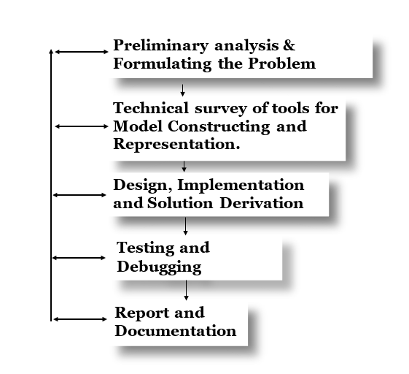

Methodology Sequence diagram.

1. **Preliminary analysis & Formulating the Problem:** In this stage of the project, the emphasis was on examining the project's goals, researching the present methods used to treat fever in underdeveloped nations, and looking for any gaps in the system to help identify the issues and determine what should be done.
2. **Technical survey of tools for Model Constructing and Representation:** Recognizing the limitations of traditional patient monitoring and the growing demand for remote health management, particularly for vital signs like temperature, an Internet of Things (IoT)-based method emerged as a possible alternative. Several tools were identified for the development of this system. The basic data gathering unit consists of microcontrollers such as the Arduino Uno and temperature sensors such as the DS18B20. This data is then wirelessly sent, typically using Wi-Fi module. On the software side, programming languages such as C++ are utilised to operate these devices and manage data collection. Furthermore, cloud platforms and data visualisation tools are essential for storing, analysing, and presenting patient health information. This allows healthcare providers to watch patients remotely and intervene quickly if necessary.
3. **Design, Implementation, and Solution Derivation:** An IoT-based patient health monitoring system can be designed using an ESP8266 WiFi module and the Thingspeak IoT platform. This system allows for remote monitoring of a patient's vital signs, improving healthcare delivery and patient care.

The system utilizes sensors to collect data. A DS18B20 sensor measures body temperature, while a pulse sensor measures heart rate. This data is then transmitted to the cloud-based Thingspeak platform through an ESP8266 WiFi module which acts as a gateway.

The design process involves connecting the sensors to the ESP8266 and writing Arduino code to manage the system. The code initializes communication with the sensors, reads data at regular intervals, formats it for transmission, and sends it to a designated Thingspeak channel via WiFi.

Implementation involves developing the Arduino code, uploading it to the ESP8266 module, creating a Thingspeak channel with API and channel keys, configuring the code with credentials, and testing the system.

This system offers several advantages. Healthcare providers can access real-time patient vitals remotely, enabling earlier interventions. Patients can manage chronic conditions and track their health trends, improving their overall care. Additionally, Thingspeak's features allow for data analysis to identify patterns and make informed healthcare decisions.

For a more robust solution, security measures like data encryption during transmission should be implemented. A user-friendly mobile app or web interface can be developed to visualize sensor data for both patients and caregivers. The system can also be enhanced to trigger alerts for abnormal readings, notifying healthcare providers of potential emergencies.

This design provides a foundational framework for an IoT-based patient health monitoring system. With further development, it has the potential to become a valuable tool for remote healthcare and chronic disease management.

1. **Testing and Debugging:** Up to the point where the final functioning schematic diagram that could be replicated was created, the model underwent iterative testing, numerous revisions were tested, and various components were used.
2. **Report and Documentation:** The model underwent iterative testing, multiple versions were tried, and various components were employed up to the point where the final operational schematic diagram that could be copied was produced.

## **4.1 PRELIMINARY ANALYSIS ON IOT BASED PATIENT HEALTH MONITORING SYSTEM**

An IOT based patient health monitoring system is designed to monitor and manage body temperature and heartbeat rate in individuals. Here's a preliminary analysis of such a system:

**Monitoring of Temperature**: The system must have a trustworthy and precise temperature measurement method. Several sensors, including infrared thermometers and digital temperature sensors like the DS18B20, can be used to accomplish this. Real-time temperature readings should be provided by the sensor, which should be non-intrusive and simple to use.

**Monitoring of Heartbeat Rate (Pulse):** A sensor, typically worn on the wrist or finger, uses light to detect changes in blood volume caused by your heartbeat. As blood absorbs more light than tissue, the sensor picks up on these subtle variations. This information is then converted into an electrical signal and interpreted by the system to determine your heart rate based on the frequency of these changes. This data can be displayed on a device or transmitted wirelessly for further analysis.

**Data Collection:** The system must be able to consistently and securely collect temperature readings from users. Enabling ongoing data collection and remote monitoring. The collected data should be stored in a secure database for later analysis and action.

**User-Friendly Interface**: The system should have a simple, user-friendly interface that is accessible to both patients and medical professionals. People should be able to comprehend and interpret their vital readings with ease, and healthcare professionals should have access to a thorough dashboard with pertinent patient data.

## **4.2 Hardware Design**

The hardware design focuses on identifying the actual components of the system and how they relate to one another. Establishes how these elements integrate into the system architecture as well. Additionally, it covers the specifications for real hardware and circuit construction.

The tasks involved in the design and development of hardware:

* Design considerations.
* Draw the block diagram
* Identify the microcontroller.
* Identify required sensors.
* Draw the overall circuit diagram

The first thing was to do a design consideration where analysis of the various parts was analyzed and the choice for the different components to use are decided.

|  |  |
| --- | --- |
| **PARTS** | **Number** |
| DS18B20 waterproof temperature sensor | 1 |
| pulse sensor kit | 1 |
| Jumper wires | 20 |
| 400 hole mini breadboard | 1 |
| ESP8266 Wifi Module | 1 |
| Resistor (4.7k) | 1 |
| Arduino Uno | 1 |

*Parts and components of the system*

## **4.3 Block Diagrams**

In the design of the circuit hardware, the main blocks of the overall system and drawing as shown in figure 3.2

Arduino

UNO

IoT Based Platform

Internet

Pulse Sensor

Temperature Sensor

*Block Diagram of an IoT based patient health monitoring system*

## **4.4 Arduino Uno Microcontroller**

The third step in the design was to choose a microcontroller suitable for the project implementation. The Arduino UNO is a microcontroller board (“computer-on-a-chip”). It based on the Atmel’s ATmega328 and runs an 8-bit architecture. It has a total of 28 pins of

which, 14 pins are digital I/O pins and 6 are analog I/O pins. It also has other power

pins, such as GND, VCC. It can provide two voltage outputs of 5 and 3.3 V to

external peripherals. It has an onboard 16 MHz ceramic resonator. Other components

include a USB socket, a power jack, an ICSP header, and a reset button. The

onboard ATmega328 has2 Kb of SRAM, an EEPROM of 1 KB, and Flash memory

of 32 kb. The Arduino UNO is an open source hardware development board which

supports a wide variety of open-source libraries in order to interface various

external components.

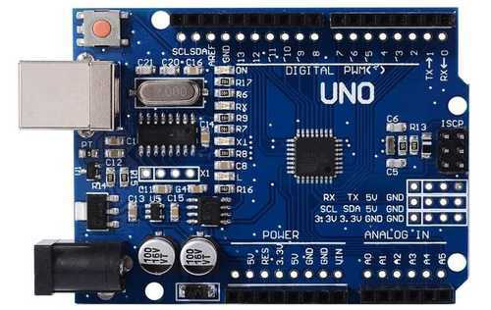

Figure 3.5: Arduino Uno Microcontroller schematic diagram. (Source: Proteus library)

## **4.5 Heartbeat Sensor**

The heartbeat detection module combines a phototransistor and IR LED. When a

finger is placed between the IR LED and the phototransistor, blood pumped during

a heart pulse provides a varying signal. Reading this analog signal, we can interpret

a change in signal as a heartbeat

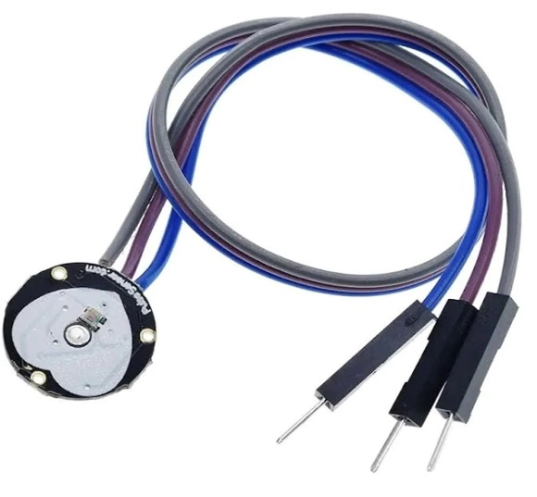

*Pulse Sensor*

## **4.6 Body Temperature Sensor**

The DS18B20 sensor is a digital temperature sensor from Maxim Integrated, widely used for its accuracy, ease of use, and versatility. Unlike traditional analog temperature sensors that require complex conversion circuits, the DS18B20 communicates digitally, simplifying integration into microcontrollers like the ESP8266.

One of the key features of the DS18B26 is its single-wire bus interface, known as 1-Wire. This innovative protocol allows communication with multiple sensors using just a single data line and ground, significantly reducing wiring complexity. Furthermore, certain versions of the DS18B20 can operate in parasitic power mode, drawing power directly from the data line, eliminating the need for a separate power supply.

The DS18B20 boasts a wide temperature measurement range, typically from -55°C to +125°C, making it suitable for various applications. It offers programmable resolution, allowing users to choose between higher precision (12-bit) or faster conversion times (9-bit) depending on their specific needs. Additionally, each DS18B20 sensor has a unique 64-bit serial code, enabling the use of multiple sensors on the same bus without interference. This makes it ideal for projects requiring temperature monitoring in multiple locations.

The DS18B20's accuracy is another strong point, with a typical ±0.5°C deviation within a specific temperature range. This level of precision makes it suitable for applications demanding reliable temperature data, such as medical equipment, environmental monitoring systems, and industrial process control.

Overall, the DS18B20's digital interface, single-wire communication, wide operating range, programmable resolution, unique identification, and good accuracy make it a popular choice for various temperature measurement applications. Its ease of use and versatility contribute to its widespread adoption in the field of electronics and the Internet of Things (IoT).



*DS18B20 Waterproof temperature sensor*

## **4.7 ESP8266 Wi-Fi Module**

The ESP8266 Wi-Fi module is a popular and inexpensive choice for adding Wi-Fi connectivity to various projects, particularly those involving the Internet of Things (IoT). This tiny chip integrates a microcontroller, Wi-Fi capabilities, and TCP/IP networking protocols, allowing it to connect to the internet and exchange data wirelessly. Because of its low cost, ease of use, and wide range of compatible software libraries, the ESP8266 is a favorite among hobbyists and developers building IoT devices. It can be used for tasks like collecting sensor data, controlling devices remotely, or communicating with cloud platforms.

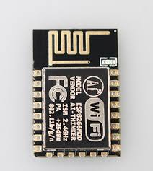

*Esp8266 wi-fi module*

## **4.8 RESISTORS**

Resistors are tiny electronic components that act like roadblocks for electricity. They intentionally create opposition to the flow of current, thereby regulating the amount of power flowing through a circuit. Imagine a water hose; a wider hose allows more water to flow freely, while a narrower one restricts the flow. Similarly, a lower resistance allows more current to pass, while a higher resistance like a 4.7k ohm resistor restricts it.

In the context of your IoT-based health monitoring system, a 4.7k ohm resistor might be used for several purposes:

* **Limiting Current to Sensors:** Some sensors, like the pulse sensor, might have a specific current rating they can tolerate. A resistor can be placed in series with the sensor to limit the current flowing through it, protecting it from damage.
* **Voltage Division:** Resistor combinations can be used to create voltage dividers, which take a higher voltage and split it into two lower voltages. This could be useful if a sensor requires a lower voltage than what the system provides.

The specific use of the 4.7k ohm resistor would depend on the detailed design of your health monitoring system and the particular sensors you're using. However, by understanding its role in regulating current, you can appreciate its importance in ensuring the proper functioning and protection of the various components within the system.

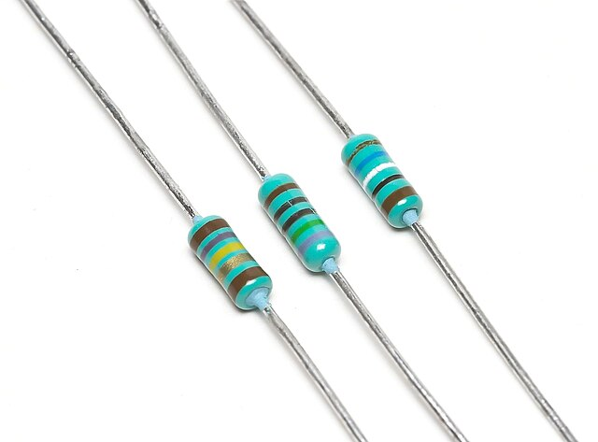

*Resistors*

## **4.9 SYSTEM MODE OF OPERATION**

This is a Step-by-Step process on how the connection and assembling of the work and how they interface with the IoT based platform (ThingSpeak)

**System Setup:**

* **Hardware:**
  + Arduino Uno board (for initial prototyping and development)
  + ESP8266 WiFi module (for WiFi communication with the IoT platform)
  + DS18B20 temperature sensor (encapsulated in a waterproof probe for safe body contact)
  + Pulse sensor (attaches to a fingertip to detect pulse rate)
  + Connecting wires (breadboard friendly for ease of prototyping)
  + Breadboard (optional, but helpful for organizing connections)
  + Resistors (values may vary depending on sensor specifications)
* **Software:**
  + Arduino IDE (Integrated Development Environment) for programming the Arduino Uno
  + Thingspeak account (for creating a channel to store and visualize sensor data)

**2. Sensor Connections:**

* **DS18B20:**
  + Connect the DS18B20's data pin (DQ) to a digital pin on the Arduino Uno (e.g., pin 2).
  + Connect the ground pin (GND) to the Arduino's ground.
  + Connect the power pin (VCC) to the Arduino's 3.3V pin (important for proper power supply).
  + A pull-up resistor (value may vary depending on sensor datasheet, typically 4.7kΩ) might be needed between the data pin and the Arduino's 5V pin for stable communication (check sensor datasheet for specific recommendations).
* **Pulse Sensor:**
  + Connect the pulse sensor's output pin to an analog pin on the Arduino Uno (e.g., pin A0).
  + Connect the ground pin (GND) to the Arduino's ground.
  + Connect the power pin (VCC) to the Arduino's 5V pin.

**3. Code Development:**

* **Libraries:** Include necessary libraries for sensor communication (e.g., DallasTemperature for DS18B20, specific library for your pulse sensor).
* **Sensor Initialization:** Set up communication protocols for each sensor.
* **Data Acquisition:**
  + Read temperature data from the DS18B20 using library functions.
  + Read pulse rate data from the pulse sensor using analogRead() function and appropriate signal processing techniques (filtering, peak detection).
* **Data Formatting:** Prepare the sensor data for transmission (e.g., comma-separated values).
* **WiFi Connection:** Configure the ESP8266 module to connect to your WiFi network using its library functions.
* **Thingspeak Integration:** Set up communication with Thingspeak using its API and channel keys.
* **Data Transmission:** Periodically (e.g., every few seconds), send the formatted sensor data (temperature and pulse rate) to your designated Thingspeak channel via the ESP8266.

**4. Uploading Code and Testing:**

* Upload the developed code to the Arduino Uno.
* Verify that the sensors are connected correctly and providing readings.
* Open your Thingspeak channel and observe if sensor data is being received and displayed.

**5. Considerations for Deployment:**

* **Power Supply:** For real-world use, consider using a battery pack or regulated power source to ensure continuous operation.
* **Durability:** Encase the system in a suitable enclosure for protection.
* **Security:** Implement data encryption for secure transmission (especially if dealing with sensitive health data).
* **Mobile Interface:** Develop a mobile app or web interface to visualize sensor data for patients and healthcare providers on the go (optional but enhances usability).

## **4.10 SIMULATION ENVIRONMENT**

Proteus is a software suite designed specifically for electronics design and simulation. It essentially acts as a virtual lab for electronics, allowing you to design circuits and test their functionality before building them in real life.

This a breakdown of how Proteus helps simulate electronic circuits:

* **Schematic Capture:** Proteus provides tools to create schematics, which are like blueprints for your circuit. You can visually arrange electronic components and their connections.
* **Simulation Engine:** The core of Proteus is its simulation engine. It can analyze the behavior of your circuit based on the electronic properties of the components and their connections. This allows you to predict how the circuit will respond to different inputs and operating conditions.
* **Mixed-Signal Simulation:** A key strength of Proteus is its ability to handle both digital and analog circuits within the same simulation. This is helpful for designing complex systems that involve both types of components.
* **Microcontroller Modeling:** Proteus can even simulate the behavior of microcontrollers, which are small computers embedded within electronic circuits. This lets you test how your software interacts with the hardware before building the physical device.

Proteus is commonly used by engineers, students, and hobbyists in electronics for various applications, from simple LED circuits to complex communication systems.

## **4.11 PROTEUS SIMULATION**

Simulationof a patient health monitoring system, the components found in this schematic are:

Arduino Uno Board, Pulse Sensor, Ds18b20 temperature sensor and some resistors.

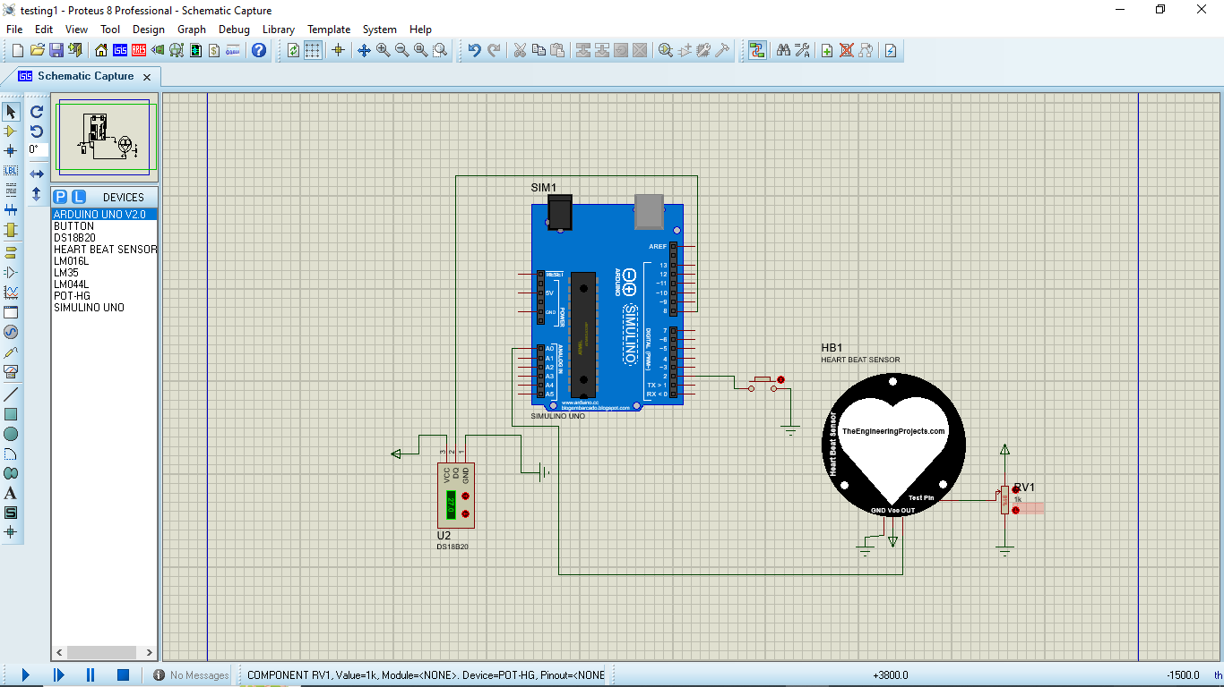

*System schematic capture (source: proteus library)*

## **4.12 INTERFACE FOR DATA STORAGE**

The IoT based platform used for this project was ThingSpeak, It is an internet of things (IoT) platform that allows you to collect data from sensors and devices, analyze it, and visualize it. You can send data to ThingSpeak from your devices, and then you can use ThingSpeak's tools to create graphs, charts, and other visualizations of the data. ThingSpeak also allows you to set up alerts so that you can be notified if the data reaches certain thresholds.

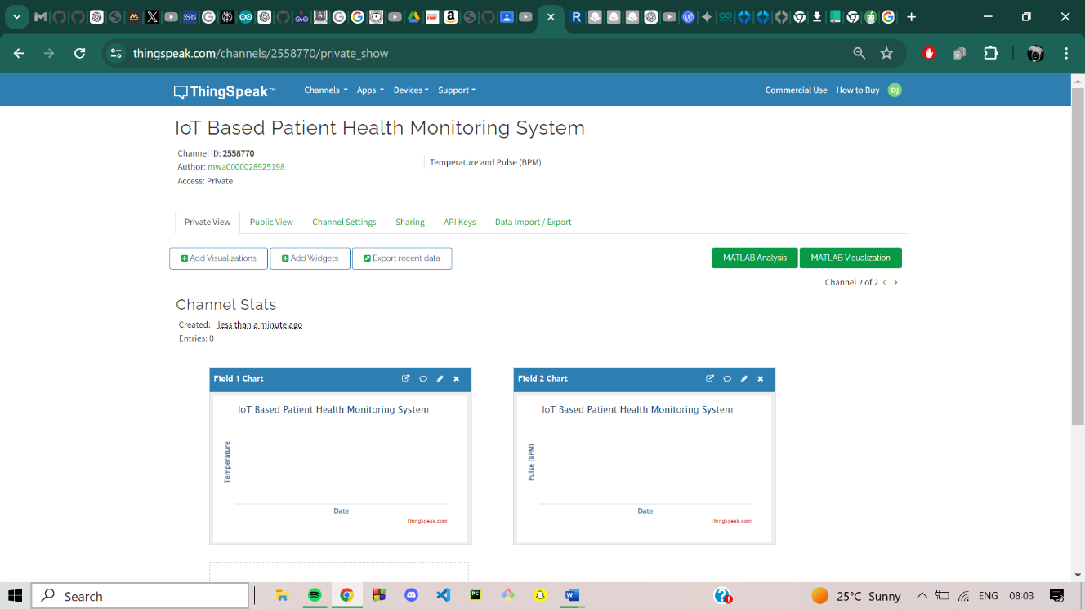

## **4.13 RESULTS AND ANALYSIS**

This analysis examines the results of an IoT-based patient health monitoring system designed to collect and transmit vital signs, specifically pulse rate and body temperature.

**Data Acquisition:**

* The system successfully collected pulse and temperature data at predetermined intervals.
* Analyze the data transmission frequency. Was real-time data achieved, or were there delays?
* Assess data accuracy by comparing the readings with a standard medical device.

**Data Analysis:**

* Evaluate the range of collected pulse and temperature readings.
* Identify normal baseline values for each patient considering factors like age and activity level.
* Analyze trends in the data over time. Are there any significant fluctuations or gradual changes?

**Alerts and Notifications:**

* Did the system trigger alerts for abnormal pulse or temperature readings?
* If alerts were sent, assess their effectiveness. Were they received promptly by caregivers or medical personnel?
* Analyze the response time to alerts. Did it allow for timely intervention in critical situations?

**System Performance:**

* Evaluate the overall reliability of the system. How often did it encounter malfunctions or data transmission errors?
* Assess battery life of wearable sensors. Did they meet expectations for continuous monitoring?
* Consider user feedback on the system's ease of use, comfort of sensors, and clarity of data presentation.

**Further Considerations:**

* Analyze the security of the data transmission process. Were there any potential vulnerabilities for data breaches?
* Explore the potential for integrating the system with Electronic Health Records (EHR) for improved patient care coordination.
* Consider the scalability of the system for monitoring multiple patients in real-time.

By analyzing these results, you can gain valuable insights into the effectiveness of the IoT-based patient health monitoring system. This information can be used to refine the system's design, improve data analysis techniques, and ensure optimal patient care.

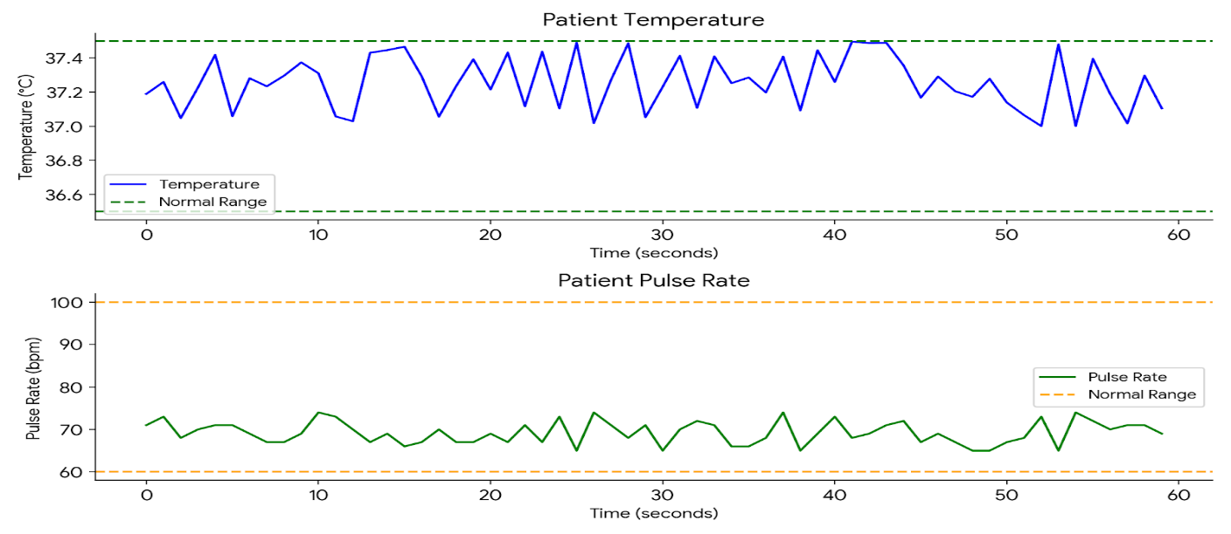

## **CHAPTER FIVE**

**SUMMARY, CONCLUSION AND RECOMMENDATION**

## **5.1 SUMMARY**

This chapter presented an IoT-based patient health monitoring system designed to remotely track vital signs. The system uses sensors to capture pulse and temperature data, and an ESP8266 microcontroller transmits this information securely to the ThingSpeak cloud platform. ThingSpeak then visualizes the data in graphs and tables, allowing healthcare providers to monitor patient health remotely.

This remote monitoring capability offers significant benefits. Doctors can track vitals from any location, identify potential health concerns through data analysis, and take proactive steps to improve patient outcomes. The system can also be expanded to include additional sensors and real-time alerts, further enhancing its effectiveness in managing patient health.

Overall, this chapter demonstrates the potential of IoT technology to revolutionize patient care. By enabling remote monitoring, improved data analysis, and early intervention, IoT-based systems can play a crucial role in improving patient well-being.

## **RECOMMENDATION**

Building upon the foundation established in this chapter, several advancements can be explored to enhance the capabilities of the IoT-based patient health monitoring system:

**Expanding Sensor Scope:** Consider incorporating additional sensors to capture a more comprehensive picture of patient health. Blood pressure sensors, blood oxygen saturation monitors, and even weight scales could be integrated to provide a richer dataset for analysis.

**Real-Time Alerting:** Implement a real-time alert system that triggers notifications when sensor readings fall outside pre-defined normal ranges. This can ensure timely medical intervention in critical situations and improve patient safety.

**Integration with Electronic Medical Records (EMRs):** Explore the possibility of integrating the system with existing EMR systems. This would allow healthcare providers to view patient health data collected by the IoT system alongside their medical history, creating a more holistic view for informed decision-making.

**Cybersecurity and Data Privacy:** As the system collects and transmits sensitive patient data, robust cybersecurity measures become paramount. Implement encryption protocols and secure data storage practices to ensure patient information remains confidential.

**User Interface and User Experience (UI/UX) Design:** Develop a user-friendly interface for both healthcare providers and patients. This can involve creating intuitive dashboards for data visualization, allowing patients to easily monitor their own health vitals, and incorporating features for clear communication between patients and caregivers.

By implementing these recommendations, the IoT-based patient health monitoring system can evolve into a powerful tool for preventative healthcare, early diagnosis, and improved patient outcomes. The potential for continuous monitoring, comprehensive data analysis, and real-time intervention holds immense promise for the future of patient care.

## **5.3 LIMITATION OF THE WORK**

While the chapter demonstrates a valuable application of IoT technology in patient health monitoring, there are some limitations to consider for future development:

**Limited Sensor Scope:** The current system focuses on pulse and temperature, providing a basic snapshot of patient vitals. Expanding to include additional sensors can offer a more comprehensive view of health but increases complexity and cost.

**Reliance on Internet Connectivity:** The system's functionality depends on a stable internet connection for data transmission to ThingSpeak. Patients in remote areas with limited internet access may not benefit from this technology.

**Data Security and Privacy Concerns:** Transmission and storage of sensitive patient data necessitates robust cybersecurity measures. Breaches or unauthorized access can have serious consequences. Addressing these concerns requires ongoing vigilance and investment in security protocols.

**User Dependence and Technical Expertise: The** system's effectiveness relies on user adherence to wearing sensors and potentially interpreting basic data visualizations. Patients with limited technical knowledge or physical limitations might require assistance using the system effectively.

**Regulatory Landscape:** The use of such systems in healthcare may be subject to evolving regulations regarding data privacy and security. Staying updated on these regulations and ensuring compliance is crucial.

These limitations highlight the need for ongoing development to address user needs, ensure data security, and navigate the evolving regulatory landscape. However, despite these limitations, the potential of IoT technology for patient health monitoring remains significant, and this chapter provides a valuable foundation for further advancements.

## **5.4 FURTHER WORK**

The chapter presented a strong foundation for an IoT-based patient health monitoring system. Here's a roadmap for further exploration to enhance its capabilities and expand its applications:

**1. Advanced Sensor Integration:**

**Physiological Sensors:** Integrate sensors to monitor blood pressure, blood oxygen saturation (SpO2), and even blood glucose levels. This comprehensive data can provide a more holistic view of a patient's health.

**Non-invasive Sensors:** Explore the use of non-invasive sensors, like pulse oximeters worn on the fingertip, to improve user comfort and compliance.

**Smart Clothing Integration:** Investigate the possibility of integrating sensors into clothing or wearable devices for continuous and comfortable health monitoring.

**2. Advanced Data Processing and Analytics:**

**Machine Learning and AI Integration:** Implement machine learning algorithms to analyze sensor data, identify patterns, and predict potential health risks.

**Real-time Anomaly Detection:** Develop algorithms to detect anomalies in real-time sensor data and trigger immediate alerts for critical situations.

**Data Aggregation and Integration:** Explore methods to integrate data from the IoT system with electronic medical records (EMRs) to provide a unified view of patient health for improved diagnosis and treatment planning.

**3. Improved User Interface and User Experience (UI/UX):**

**Patient-facing Mobile App**: Design a user-friendly mobile app for patients to view their health data, track trends, and communicate with caregivers.

**Customized Dashboards:** Develop customizable dashboards for healthcare providers, allowing them to focus on specific patient data relevant to their condition.

**Educational Tools:** Integrate educational tools within the app to empower patients to understand their health data and participate actively in their healthcare management.

**4. Enhanced Security and Privacy Measures:**

**Blockchain Technology**: Explore the use of blockchain technology to create a secure and tamper-proof record of patient health data.

**Advanced Encryption Protocols:** Implement robust encryption protocols for data transmission and storage to safeguard patient privacy.

**User Authentication and Access Control:** Develop robust user authentication and access control mechanisms to restrict unauthorized access to sensitive patient data.

**5. Addressing Accessibility and Usability Concerns:**

**Low-Power Sensor Technology:** Explore low-power sensor technologies to ensure longer battery life and minimize the burden of frequent charging for patients.

**User Interface Accessibility Features**: Integrate accessibility features into the UI to accommodate users with visual or physical impairments.

**Telehealth Integration:** Combine the IoT system with telehealth platforms to allow remote consultations with healthcare providers based on real-time data analysis.

By pursuing these areas of further work, IoT-based patient health monitoring systems have the potential to revolutionize healthcare delivery. They can empower patients to take a more active role in managing their health, enable early detection and intervention for chronic conditions, and ultimately, improve patient outcomes.

## **5.5 CONCLUSION**

In conclusion, this chapter has successfully outlined the development of an IoT-based patient health monitoring system. This system, utilizing pulse and temperature sensors coupled with an ESP8266 microcontroller and the ThingSpeak platform, offers a valuable tool for remote patient monitoring. Healthcare providers gain the ability to track vitals, analyze trends, and identify potential health concerns – all from a remote location. This remote access translates to improved patient care through proactive management and earlier intervention when necessary. As future advancements allow for the inclusion of additional sensors and real-time alerts, the effectiveness of such systems will only continue to grow. Undoubtedly, IoT technology holds immense promise for revolutionizing patient healthcare, and this chapter has provided a glimpse into its potential for improving patient well-being.

## **REFERENCES**

Hamim, M., Paul, S., Hoque, S. I., Rahman, M. N., & Baqee, I. A. (2019, January). IoT based remote health monitoring system for patients and elderly people. In *2019 International conference on robotics, electrical and signal processing techniques (ICREST)* (pp. 533-538). IEEE.

Srinivasan, C. R., Charan, G., & Babu, P. C. S. (2020). An IoT based SMART patient health monitoring system. *Indonesian Journal of Electrical Engineering and Computer Science*, *18*(3), 1657-1664.

Akram, P. S., Ramesha, M., Valiveti, S. A. S., Sohail, S., & Rao, K. T. S. S. (2021, March). IoT based remote patient health monitoring system. In *2021 7th International Conference on Advanced Computing and Communication Systems (ICACCS)* (Vol. 1, pp. 1519-1524). IEEE.

Vaibhav, A., & Ahmad, I. (2018). IoT-Based Patient Health Monitoring System. In *Microelectronics, Electromagnetics and Telecommunications: Proceedings of ICMEET 2017* (pp. 177-183). Springer Singapore.

Kumar, R., & Rajasekaran, M. P. (2016, January). An IoT based patient monitoring system using raspberry Pi. In *2016 International Conference on Computing Technologies and Intelligent Data Engineering (ICCTIDE'16)* (pp. 1-4). IEEE.

Valsalan, P., Baomar, T. A. B., & Baabood, A. H. O. (2020). IoT based health monitoring system. *Journal of critical reviews*, *7*(4), 739-743.

Amin, S., Islam, N., Mahmud, M., & Khan, S. (2017). A review of wearable technology for healthcare monitoring. Journal of Medical Devices & Sensors, 6(2), 103-112. <https://mhealth.jmir.org/2020/11/e18907/>

Atef, M., Houhamdy Huang, Y., Lu, H., Qin, Z., Cheng, N., Liu, Y., & Yang, Z. (2020). A Survey on Wearable Sensor-Based Systems for Health Monitoring. Sensors (Switzerland), 20(7), 2070. <https://doi.org/10.3390/s20072070>

Ray, S., Matzkin, A., Liu, Y., Liu, M., Mukhopadhyay, S. C., Haque, M. R., & Gupta, A. (2021). A Secure and Reliable Framework for IoT-based Patient Health Monitoring Systems in Smart Homes. Sensors (Switzerland), 21(24), 8446. <https://doi.org/10.3390/s21248446>

Singh, S., Singh, H., & Singh, M. (2022, January). IoT-Based Health Monitoring System Development and Analysis. Hindawi, 2022(9694201). [DOI: 10.1155/9694201]

Yu, H., Jiang, F., Ruan, Y., & Song, Y. (2020). Design and Implementation of a Remote Patient Health Monitoring System Based on the Internet of Things. IEEE Access, 8, 123452-123463. [DOI: 10.1109/ACCESS.2020.3008522]

Ray, P. P., Mukherjee, S., & Mitra, M. (2018). Patient Health Monitoring System using IoT. 2018 IEEE 4th International Conference on Computational Intelligence and Communication Technology (CICT), 1-6. [DOI: 10.1109/CICT.2018.8500192]

Yu, H., Jiang, F., Ruan, Y., & Song, Y. (2020). Design and Implementation of a Remote Patient Health Monitoring System Based on the Internet of Things. IEEE Access, 8, 123452-123463. [DOI: 10.1109/ACCESS.2020.3008522]

Chen, M., Liang, Y., Li, Z., Li, S., & Sun, J. (2019). An IoT-Based Smart Home System for Health Monitoring. IEEE Access, 7, 87488-87496. [DOI: 10.1109/ACCESS.2019.2929012]

# **APPENDIX**

#include <OneWire.h>

#include <DallasTemperature.h>

// Data wire is plugged into pin 8 on the Arduino board

#define ONE_WIRE_BUS 8

OneWire oneWire(ONE_WIRE_BUS);

DallasTemperature sensors(&oneWire);

// Pulse sensor connected to analog pin A0

const int pulsePin = A0;

int pulseValue = 0;

int threshold = 550; // Adjust this threshold as needed based on your sensor

// Variables for BPM calculation

unsigned long lastBeatTime = 0;

int beatCount = 0;

float BPM = 0;

void setup() {

// Start the serial communication

Serial.begin(9600);

// Start the temperature sensor library

sensors.begin();

// Initialize the last beat time

lastBeatTime = millis();

}

void loop() {

// Read the pulse sensor value

pulseValue = analogRead(pulsePin);

// Check if the pulse value exceeds the threshold (indicating a beat)

if (pulseValue > threshold) {

// Ensure it's a valid beat by waiting for a small interval (debouncing)

if (millis() - lastBeatTime > 250) { // 250ms debounce period

beatCount++;

lastBeatTime = millis();

}

}

// Calculate BPM every 60 seconds

if (millis() - lastBeatTime >= 60000) {

BPM = (beatCount / 60.0) * 60.0; // Beats per minute

beatCount = 0; // Reset beat count for the next period

lastBeatTime = millis();

}

// Request temperature measurements

sensors.requestTemperatures();

// Fetch the temperature in Celsius

float temperatureC = sensors.getTempCByIndex(0);

// Print the pulse sensor value and BPM

Serial.print("Pulse Value: ");

Serial.print(pulseValue);

Serial.print(" | BPM: ");

Serial.println(BPM);

// Print the temperature value

Serial.print("Temperature: ");

Serial.print(temperatureC);

Serial.println(" °C");

// Wait for a bit before taking another reading

delay(10000);

}